Depth First Search (DFS)
Aim
To implement the Depth First Search (DFS) algorithm for traversing a graph.
Procedure
- Create the graph.
- Select the starting node.
- Mark the starting node as visited.
- Visit an adjacent unvisited node recursively (or using a stack).
- Continue until all reachable nodes are visited.
- Stop when all nodes have been traversed.
Output
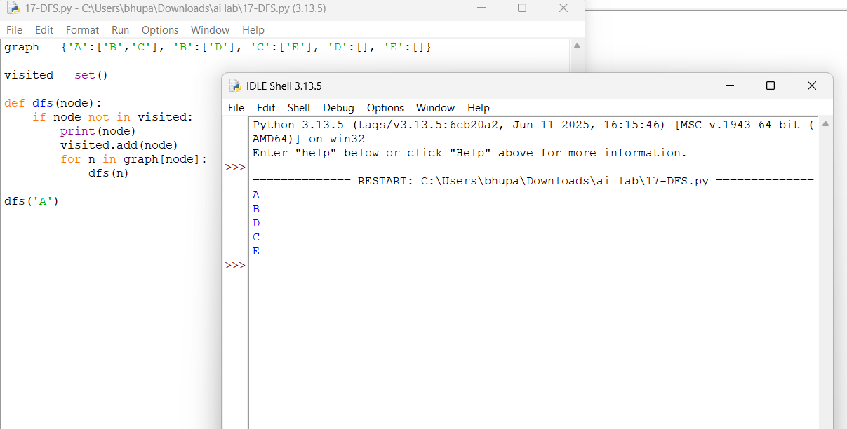
Result
The graph was successfully traversed using the Depth First Search (DFS) algorithm.

